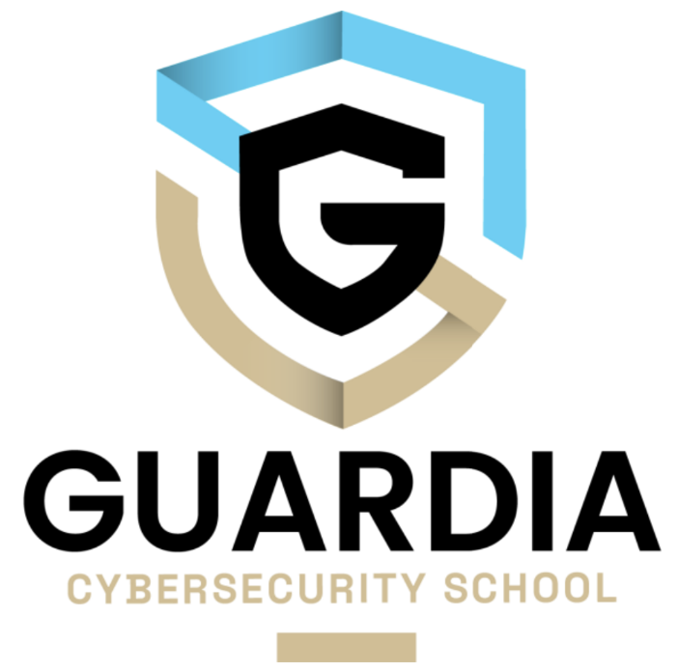

Leelou Lerouge - Guardia 2

26/11/2023

# Summary text of “Cybersecurity Challenges in Small to Medium Enterprises”

In the beginning of the video John Solomon introduces the guest speaker, Jilian Quang a research scientist Cybersecurity at MIT Sloan (CAMS). They talked about her background in communication and then focused on data privacy in cybersecurity. Then she talked about her methodology based on interviews, case study and participative observation.

One of the principal challenges of the small and medium company is the complexity of application update. On the other hand Jilian underlines the necessity of resources to understand and find useful resources.

She also underlines the crucial need of collaboration between authorities, industry and small companies to treat this information amount. Jilian highlights the difficulties for those companies to work on this amount of available resources and interpret the instruction.

The equity of the required exigence of small companies is also a subject matter. She highlights that even though they are part of a larger supply chain, these smaller businesses must follow similar rules, although accessing the necessary information can be a challenge.

A new scheming proposition is to automatise the conformity mechanism with the help of AI technology, giving a potential to help small businesses to raise these challenges. However, Jilian insists that they must focus on the resolution of the problem instead of the acceleration of the existing process.

The importance of quality research in cybersecurity is also discussed. Jilian explains how this approach allows a better understanding of human behavior and decision taking. She highlights that the combination of research qualitative and quantitative is essential to a complete approach.

At the end of the video, Jilian shared her point of view on the importance of a multidisciplinary approach in information security, highlighting the crucial importance of the organizational culture in cybersecurity. In conclusion, she mentioned her future project in organizational culture and cybersecurity value.